Title

A. Author¹, B. Author², and C. Author^{1,2}*

¹Affiliation, full postal address, including country
² Affiliation, full postal address, including country

* corresponding author e-mail: a.author@mail.com

Abstract (up to 100 words)
Article (up to 4 pages) should be prepared in English according to the rules.
The article may include Abstract (necessarily), Keywords (necessarily), Introduction(necessarily), Experimental, Results and Discussion, Conclusion (necessarily), Acknowledgement, and References.

Keywords: no more than five separated by commas.

Introduction
Text with a first-line indent (10 mm), alignment — justified, figures and reference numbers should be included in the text. Margins: top — 25 mm, left — 20 mm, right — 20 mm, bottom — 35 mm. Font: Times New Roman, 12 (single-spaced).

Experimental
Figures should be inserted into the text as one-piece objects. Figures resolution should be not less than 300 dpi, in raster format (tif, jpg, etc.). The text in figures must be readable and not intersected. Figure borders should not extend beyond the page margins. Figures may be colored. Figures created in MS Word are not accepted. Figures should be numbered and have captions (ex., Figure 1). Captions should be below the picture. Do not use italics or bold font.

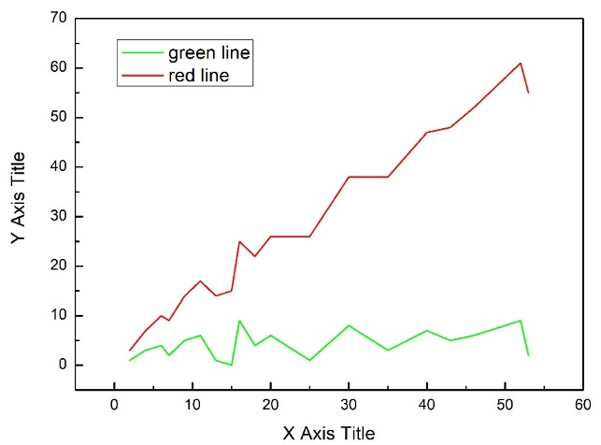
Figure 1. Figure caption

Results and discussion
Equations must be typed by the Equation Editor. Do not use equations as pictures. Numbering, if it is necessary, should be placed in brackets on the right. Small equations can be placed directly in the text without using the equation editor (italic font, except numbers). For example: R = β·a² + b₁/c.

$a=\frac{b}{c}$, (1)

Tables presented in the text should be numbered and titled. Table title should be aligned in the center of the page. The title is placed above the Table. Table borders should not extend beyond the page margins.

Table 1. Table title
Column 1 | Column 2

Conclusion
The article should be sent to conf.apssp@yandex.by no later than March 15, 2023.

Acknowledgment

References:
[1] A. Author [et al.] Book. Publisher (Year) Pages. (for book)
[2] A. Author [et al.] Journal Title Abbreviation Volume (Year) Pages. (for articles)
The reference numbering should strictly correspond to their mention order in the text.

